
ANDERSON JUNIOR COLLEGE
Preliminary Examination 2012

Name:__________________________________ PDG:_____/11

Pharmaceutical Chemistry 9812
Higher 3

Friday
19 Sep 2012 2h 30 min

READ THESE INSTRUCTIONS FIRST

Write your name and PDG number on all the work you hand in.
Write in dark blue or black pen on both sides of the paper.
You may use a soft pencil for any diagrams or graphs.
Do not use staples, paper clips, highlighters, glue or correction fluid.

Answer any five questions.
Begin each question on a fresh page.
At the end of the examination, fasten all your answer scripts together.

The number of marks is given in brackets [ ] at the end of each question or part question.
You are reminded of the need for clear presentation in your answers.

In the table below, circle the question numbers you have attempted.

Question | Tr1 | Tr2 | Tr3 | Tr4 | Tr5 | Tr6 | Total
1
2
3
4
5
6
Grand Total |  |  |  |  |  |  | /100
______________________________________________________________________________

This question paper consists of 14 printed pages and 1 blank page.

Blank Page

1 | (a) | All the following compounds consist of at least a nitrogen atom in the structures.  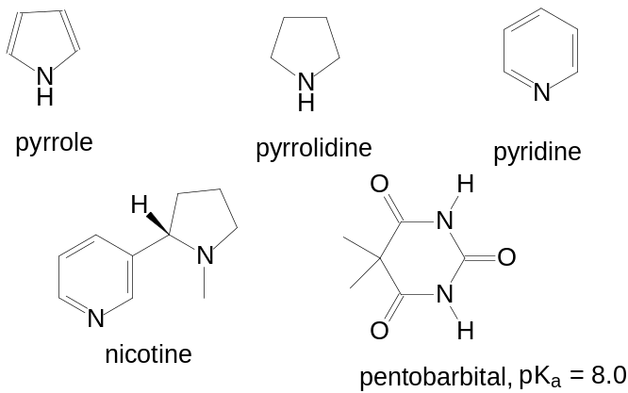
 |  | (i) | Nicotine consists of two nitrogen atoms in its structure. Compare the relative basicity of pyrrole with these two nitrogen atoms in nicotine.  Explain your answer. [3]
 |  | (ii) | Benzene reacts with CH₃Cl in the presence of a suitable catalyst, AlCl₃.  Predict and explain, as fully as you can, the reactivity of pyridine under similar conditions.  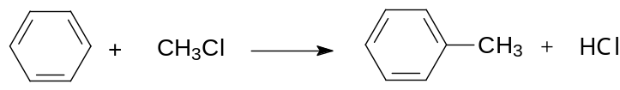  [2]
 |  | (iii) | Most nitrogen containing compounds are basic. However, pentobarbital, a drug commonly prescribed to treat seizures is a weak acid. With the aid of resonance structures, explain why pentobarbital is a weak acid. [1]
 |  | (iv) | Pentobarbital is often formulated as its sodium salt to make them water soluble. However, ionised salts of pentobarbital do not cross biological membranes very well. Calculate the percentage of a dose of pentobarbital that will be ionised at plasma pH (7.4). [2]

 | (b) | Both adenosine and acetylcholine are natural stimulants that increase the amount of adrenaline in the blood stream in human body. The adrenaline in turn binds at the adrenergic receptors to result in the necessary physiological effects.  Adenosine binds at the adenosine receptors on the surfaces of the cells in the central nervous system (CNS) while acetylcholine binds at the acetylcholine receptors.  The following are three alkaloids that have stimulating effects. Ephedrine is an active constituent of herbal remedies that contain the dried plant material ma-huang.  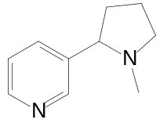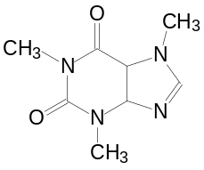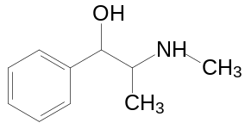  nicotine caffeine ephedrine
  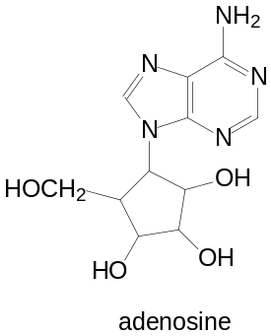 | 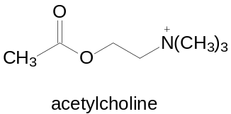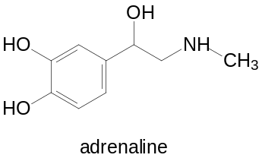
 |  | (i) | Explain the term stimulants. | [1]
 |  | (ii) | Discuss the modes of action of nicotine and caffeine as stimulants. | [2]
 |  | (iii) | Hence, suggest and explain a likely structure that nicotine exists in at its binding site in the physiological pH of 7.4. [2]
 |  | (iv) | Ephedrine acts as an agonist for adrenergic receptors. Describe the interactions it has with the receptor. [2]
 |  | (v) | Suggest why ephedrine crosses the blood-brain barrier more easily than adrenaline. [1]

 | (c) | Drugs are usually administered at regular time intervals to keep the blood levels of drug within a maximum and a minimum level, such that they are not too high to be toxic, yet not too low to be ineffective.  The ratio between the toxic dose and the lowest effective dose is called the therapeutic index, TI.  TI = maximum dose before toxic symptoms occur  minimum effective dose  The table below shows the fluctuation in the concentration levels of a drug Z (M_{r}, 189) in blood serum with a regular dosing of 4 hourly intervals.
  Time of dosing (h) | 0 | 4 | 8 | 12 | 16 | 20 | 24 | 28
  Maximum level (μg/ml) | 1.0 | 1.5 | 1.75 | 1.87 | 1.94 | 1.97 | 1.98 | 1.98
  Minimum level (μg/ml) | 0.5 | 0.75 | 0.87 | 0.94 | 0.97 | 0.98 | 0.99 | 0.99
 |  | (i) | Explain the fluctuation in the concentration of drug Z before it reaches to a steady state. [1]
 |  | (ii) | Calculate the average steady state concentration of drug Z in mol dm⁻³. | [2]
 |  | (iii) | The maximum concentration of drug Z in the blood before toxic symptoms occur is 1.32 x 10⁻⁸ mol/ml.  Assuming that the average steady state concentration of Z is the minimum effective dose, calculate the therapeutic index, TI of the drug. [1]
[Total: 20]

2 | (a) | Many drugs have been developed to manage migraines, a prevalent ailment in modern society. Sumatriptan is the first synthetic drug used in the treatment of migraine headaches. It relieves migraine by reducing vascular inflammation. Pizotifen is a drug used to prevent migraines. Both sumatriptan and pizotifen interact with receptors for serotonin, a neurotransmitter found in the brain. While sumatriptan is an agonist, pizotifen is an antagonist for serotonin receptors.
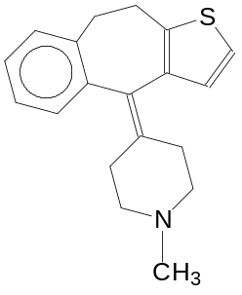
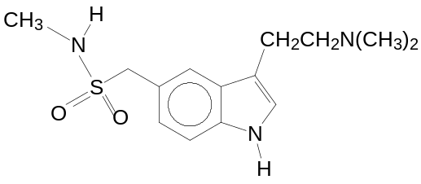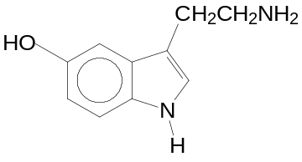

sumatriptan pizotifen serotonin

 |  | (i) | Explain how agonists and antagonists differ in their interactions with receptors. [2]
 |  | (ii) | Identify 3 possible types of interactions between sumatriptan and its receptor, stating which groups on sumatriptan give rise to them. [3]
 |  | (iii) | Sumatriptan is available in different formulations; such as tablets, subcutaneous injections and nasal sprays.  Give one advantage of administrating the drug as a nasal spray. [1]
 | (b) | The four compounds below are also analgesics available commercially.  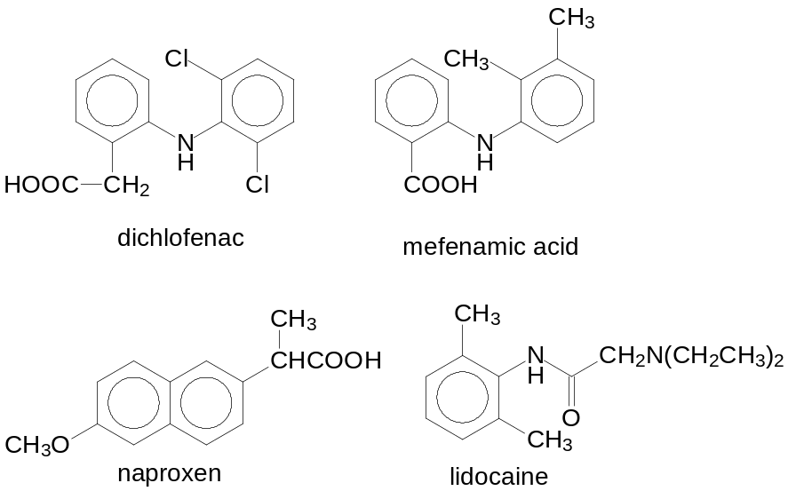

 |  | (i) | Analgesics can be classified as narcotic or non-narcotic. State the class of analgesic for mefenamic acid. Hence, briefly explain the mode of action of this class of analgesic. [2]
 |  | (ii) | The table below lists 3 consecutive peaks in the mass spectrum of one of the four analgesics.  Identify the analgesic and the fragment ion responsible for the mass spectrum. Give your reasoning. [4]
  Mass number of peak | Relative intensity
  277 | 243
  279 | 162
  281 | 27
 |  | (iii) | Identify the compound responsible for the ¹H-NMR spectrum in CDCl₃ solution shown below.  Assign the signals to the particular protons in the molecule. Explain your answer fully. [6]
  δ | integration | splitting
  8.84 | 1 | singlet
  7.05 | 3 | complex
  3.09 | 2 | singlet
  2.91-2.38 | 4 | quartet
  2.22 | 6 | singlet
  1.18 | 6 | triplet
 |  | (iv) | Suggest why the addition of deuterium oxide (D₂O) to the NMR spectrum allows the identification of labile protons.  Identify all the labile protons in the four compounds. [2]
 |  |  | [Total: 20]

3 | (a) | Heterocycles are extremely important in pharmaceutics and biochemistry. A lot of human biomolecules and drug molecules are made up of heterocycles. Sezolamide, the ocular carbonic anhydrase inhibitor consists of a thiophene in its structure. Ranitidine (Zantac®) belongs to a group of drugs called histamine−2 blockers, also has a furan ring. Ranitidine is used to treat and prevent ulcers in the stomach and intestines.  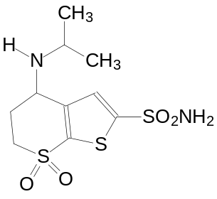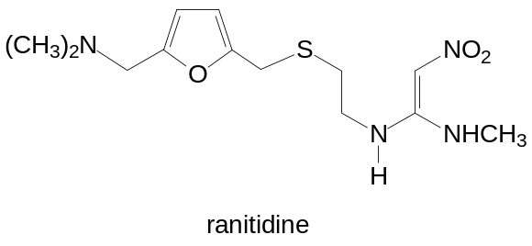  sezolamide  The following questions involved the synthesis of the two drugs.
A possible way to synthesize the bicyclic ring in sezolamide is shown below.

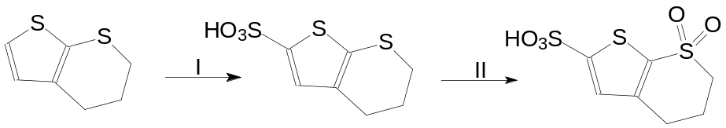
 |  | (i) | State the reagents for step I and II. | [2]
 |  | (ii) | Explain why the substitution occurs at position 2 in the thiophene ring in step I. [2]
 |  | The following scheme outlines the synthesis of ranitidine from furfural, which can be produced very cheaply from waste vegetable matter.
 |  | 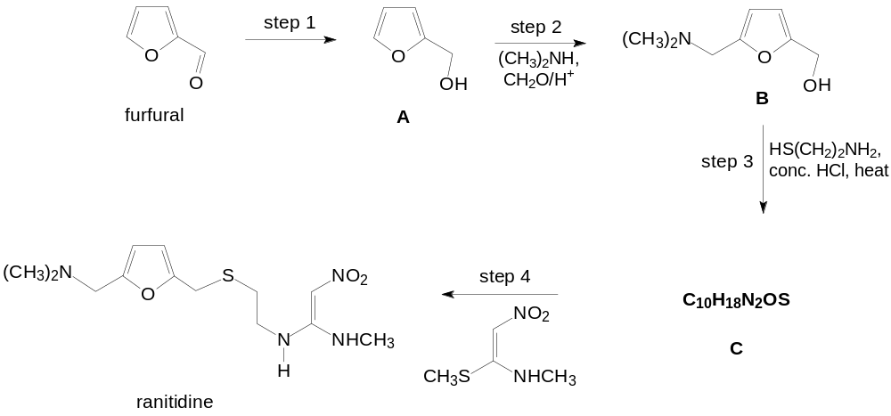
 |  | (iii) | State the type of reaction for step 1. Suggest reagents and conditions. [2]

 |  | (iv) | Conversion of A to B in step 2 is initiated by the protonation of formaldehyde (CH₂O) to form the iminium ion intermediate.  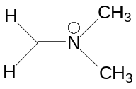  iminium ion  Suggest the mechanisms for the formation of iminium ion and hence, for the formation of compound B from A [5]
 |  | (v) | Suggest the structural formula of compound C. | [1]
 |  | (vi) | Explain with the aid of diagrams, the significance of the –NO₂ group in the reagent used in step 4. [2]
 | (b) | Tobacco smoke may contain more than 4000 chemicals, which could have various toxic, mutagenic and carcinogenic effects. Pyridine and quinoline are examples of such chemicals. The content and concentration of these chemicals can vary widely from one brand of cigarette to the next. Analysis of the content in samples of smoke from different brands may be done by ultra-violet spectroscopy.  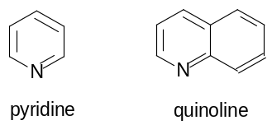
 |  | (i) | Below shows the UV/VIS spectra A and B of two solutions, one containing pyridine and the other containing quinolone, each at an equal concentration of 3.30 x 10⁻⁵ moldm⁻³.  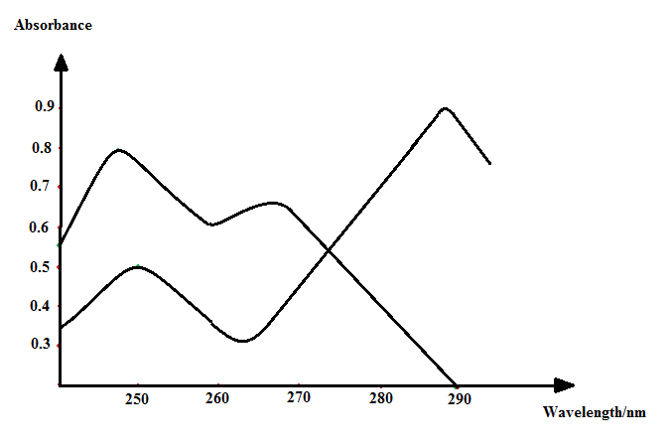  A  B  0  Identify the two spectra, A and B, with appropriate reasons. [2]
 |  | (ii) | A new sample containing a mixture of pyridine and quinoline was collected and analysed with UV/VIS spectroscopy at 250 nm and 290 nm. The absorbance at each wavelength was recorded as shown.  State Beer Lambert’s law and hence, determine the concentration of pyridine and quinolone in this sample. [2]
  Wavelength/nm | Absorbance
  250 | 0.92
  290 | 0.50
 |  | [Total: 20]

4 | (a) | 2-chlorocyclohexanol can exist as stereoisomers.  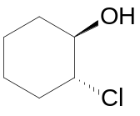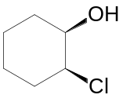  trans-isomer cis-isomer
 |  | (i) | Draw the Newman projections to illustrate the two staggered chair conformations of the trans-isomer. Explain which conformation has a lower energy. [3]
 |  | (ii) | What is the stereochemical relationship between the cis- and trans-2-chlorocyclohexanol?  Explain how a racemic mixture of either compound may be resolved into the two enantiomerically pure forms. [2]
 |  | (iii) | The reactivity of cis- and trans 2-chlorocyclohexanol with NaOH differs.
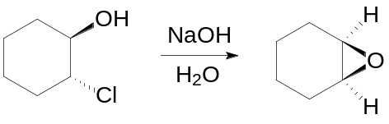

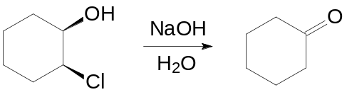

Explain the difference in the reactivity. You may find it helpful to use diagrams to illustrate your answers. [4]
 | (b) | Ketoprofen and ibuprofen are non-steroidal anti-inflammation drugs (NSAID) used in commercial formulations for relieving pain and inflammation associated with arthritis. Both drugs are produced as a racemate, but only the S-enantiomer has pharmacological activity.
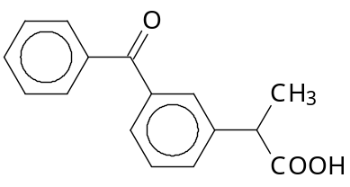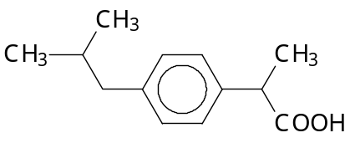
ketoprofen ibuprofen

 |  | (i) | Give 3 reasons why all drugs are regulated for stereoisomer content. [3]
 |  | (ii) | Draw the Fisher projection of S-ketoprofen, showing clearly the stereochemistry around the chiral carbon. [1]
 |  | (iii) | Ketoprofen is classified as a non-competitive inhibitor of prostaglandin synthetase. Explain the term non-competitive inhibitor. [1]

The table below shows the data of an investigation to study the relative analgesic activity of a series of compounds related to ibuprofen on rat brain.

Compound | Structure | Analgesic activity relative to ibuprofen
ibuprofen |  | 1
ketoprofen |  | 0.42
T | 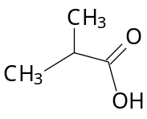 | Inactive
U | 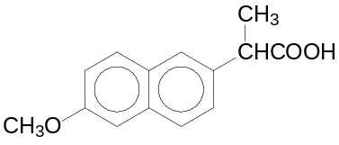 | 0.49
V | 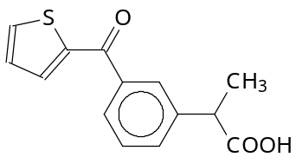 | 4

 |  | (iv) | Based on the data above, explain your deductions clearly, the possible interactions that ibuprofen can form with prostaglandin synthetase. [3]
 |  | (v) | Suggest why only S-ketoprofen has a pharmacological effect, but not the other.[1]
 |  | (vi) | Suggest a chemical modification to the structure of S-ketoprofen which might improve its efficiency for use as a transdermal drug (drug applied to skin).  State the reagents for this conversion. [2]
 |  |  | [Total: 20]

5 | (a) | Penicillins are a group of antibiotics which inhibit the synthesis of cell walls in some bacteria. Penicillin G, the parent of these antibiotics, was first isolated from a fungal species, Penicillium notatum.  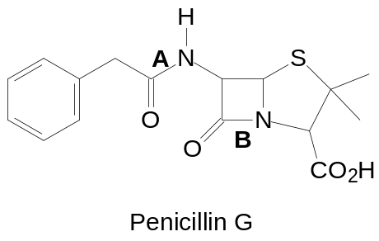  The presence of the β-lactam ring in penicillin is essential in the study of structure-activity relationship (SAR).
The bond lengths of the two C-N bonds A and B in Penicillin G are indicated below.

Bond length
Bond A 0.132 nm
Bond B 0.147 nm

Explain the difference in the bond length of A and B.

Hence, compare the rate of hydrolysis of the amide and lactam groups in Penicillin G. Explain your answer. [4]

 | (b) | Cephalosporin is the second major group of β-lactam antibiotics. The first cephalosporin (cephalosporin C) was derived from a fungus obtained in the 1940s from sewage water on the island of Sardinia.  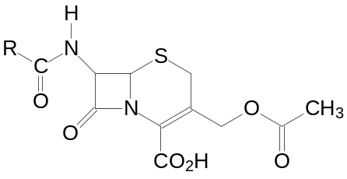  Cephalosporin
 |  | (i) | A study of the structure of cephalosporin reveals that it can be formed from two amino acids and two carboxylic acids.  Identify the structures of the two amino acids. [2]
 |  | (ii) | Given that the two hydrogen atoms in the 4-membered ring of Cephalosporin are cis to each other, use all the information given to draw the structure of Cephalosporin, showing the correct stereochemistry around all the chiral centres.  [1]
 |  | (iii) | Identify three more functional groups in Cephalosporin other than amide and lactam. [2]
 |  | (iv) | Briefly discuss the action of cephalosporin on bacteria. [1]
 |  | (v) | Cephalosporin in general is more resistant towards β-lactamase than penicillin.  Using the data in (a), predict the bond length of C-N bond in the lactam ring of cephalosporin. Explain your reasoning. [2]
 |  | (vi) | Hydrolysis of β-lactam in cephalosporin results in the loss of CH₃COO⁻.  Copy the following diagram and suggest a possible mechanism for this reaction.  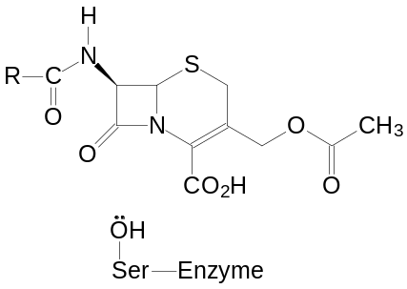 [3]
 |  | (vii) | A disadvantage of cephalosporin is the fact that the acetyloxy group is readily hydrolysed by esterase enzymes to give the less active alcohol.  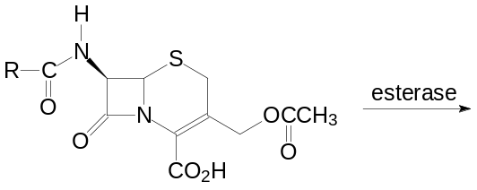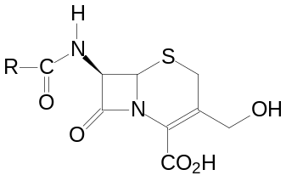  Decrease in activity  With reference to (b)(vi), give an explanation for the difference in activity. [1]
 | (c) | Nystatin is used to treat fungal infections of the skin, mouth, vagina, and intestinal tract. It has the following structure.
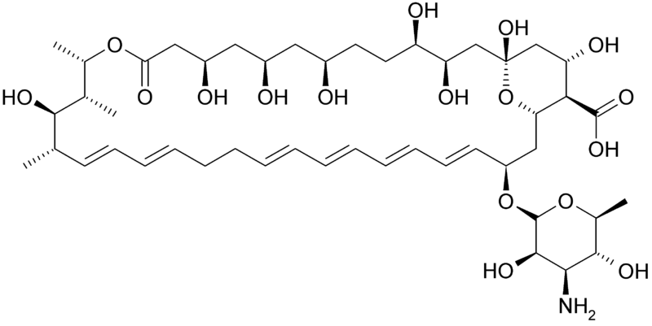
Nystatin

 |  | (i) | Based on the structure, suggest a possible mode of action of nystatin. Explain your answer. [3]
 |  | (ii) | State one other way, with an example of such a drug, in which anti-bacterials work. [1]  [Do not suggest those describe in (b) and (c)(i).]
 |  |  | [Total: 20]

6 | (a) | Morphine was discovered as the first active alkaloid extracted from the opium poppy plant in 1804. The drug was first marketed to the general public in 1817 as a narcotic analgesic. It was first synthesized and patented by Dr. Marshall D. Gates, Jr. at the University of Rochester in 1952.
The following reaction scheme shows Gates’ total synthesis of morphine from
6-dihydroxynaphthalene.

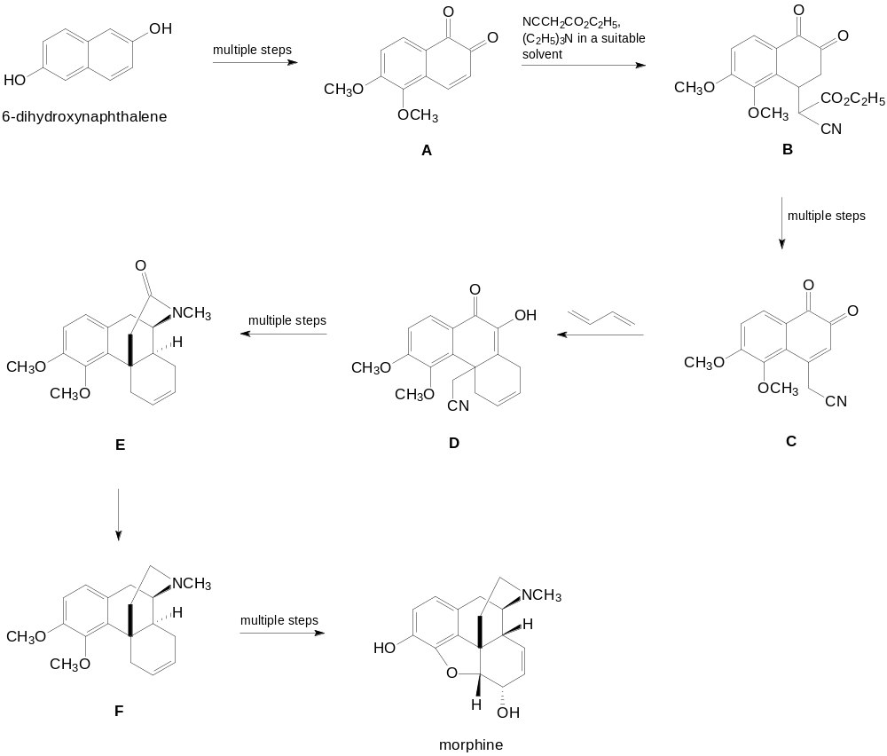
 |  | (i) | Suggest a mechanism for the formation of B from A and for the formation of D from C. [5]
 |  | (ii) | What type of reaction is the formation of F from E? | [1]
 |  | (iii) | State any two groups in morphine that are responsible for its physiological effects.  [2]

 | (b) | The structures of some narcotic analgesic molecules, morphine, heroine and acetylmorphine are given below.  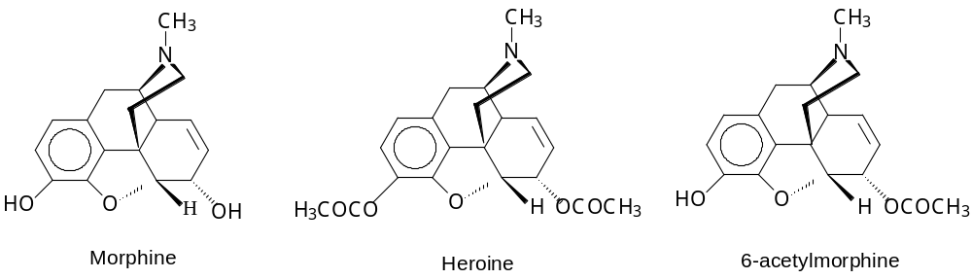
 |  | (i) | Outline the principles of reversed phase HPLC chromatography. | [3]
 |  | (ii) | Explain how it can be used to separate the 3 compounds: morphine, heroine and 6-acetylmorphine and why it is more preferred over the use of normal phase HPLC chromatography. [3]
 |  | (iii) | Suggest why gas chromatography cannot be used to separate these three compounds. [2]
The following shows the chromatogram of a sample containing the three compounds.

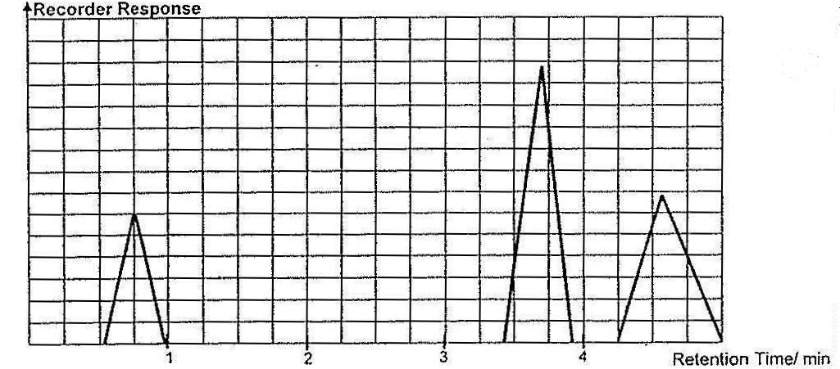

 |  | (iv) | Suggest and explain the mode of detection that can be employed for the chromatogram shown above. [2]
 |  | (v) | Calculate the concentration ratio of the three compounds in the sample, showing your working clearly. [2]
 |  |  | [Total: 20]

END OF PAPER

